**System Requirement Specification**

Broadcasting and Radio License Management System

Department of Information and Broadcasting, Government of Nepal

SRS Report, Version 2.0, 5th Magh, 2078

Submitted by



Upveda Technology Pvt. Ltd.

Madan Bhandari Path, New Baneshwor-31, Kathmandu

##### Document History

|  |  |  |  |  |  |
| --- | --- | --- | --- | --- | --- |
| Date | Version | Author | Reviewed by | Approved by | Description |
| 2078-09-19 | 1.0 | Abichar Bohara | Subodh Raj Satyal |  | Initial Draft |
| 2078-10-04 | 2.0 | Abichar Bohara | Subodh Raj Satyal |  | Updated as per DoIB Feedback |

##### Table of Contents

1. Introduction 6

1.1. Project Background 6

1.2. Project Objectives 7

1.3. Purpose of this Document 7

1.4. Structure of this Document 7

Functional Requirements: 7

Other Requirements: 8

Operational Requirements: 8

Formatting 9

2. Functional Requirements 10

2.1 Context 10

2.2. User Requirements 10

2.3. Process Flow Diagrams 16

2.4. Functional Requirements 36

2.4.1. Functional RequirementGroup1: User Authentication/Access 36

2.4.2 Functional RequirementGroup2: Dashboard 37

2.4.3. Functional RequirementGroup3: Configuration Management 39

2.4.4. Functional RequirementGroup4: Permit Management 42

2.4.5. Functional RequirementGroup5: License Management (FR: 031) 43

2.4.6. Functional RequirementGroup5: Renew Management (FR: 032) 44

2.4.7. Functional RequirementGroup5: Royalty Management (FR: 033) 44

2.4.8. Functional RequirementGroup5: Sajaya Adesh Management (FR: 034) 45

2.4.9. Functional RequirementGroup5: Foreign Curency Exchange Management (FR: 035) 45

2.4.10. Functional RequirementGroup5: Import Recommendation Management (FR: 036) 45

2.4.11. Functional RequirementGroup5: Integration Management (FR: 037) 45

2.4.12. Functional RequirementGroup6: Profile and Notification Management 46

2.4.13. Functional RequirementGroup8: User Management (FR:040) 46

2.4.15. Functional RequirementGroup8: Reports (FR:041) 47

3. Other Requirements 49

3.1. Interface Requirements 49

3.2. Hardware Interfaces 50

3.3. Software Interfaces 51

3.4. Data Conversion Requirements 51

3.5. Hardware/ Software Requirements 51

3.5.1 Hardware Requirements 51

3.5.2 Software Requirements: 52

4. Operational Requirements 53

4.1. Security and Privacy 53

4.2. Audit Trail 54

4.3. Recoverability 54

4.4. System Availability 54

4.5. General Performance 55

4.6. Capacity 55

4.7. Data Retention 55

4.8. Error Handling 55

4.9. Validation Rules 56

4.10 Conventions/ Standards 56

APPENDIX-A-GLOSSARY 58

APPENDIX-B- Assumptions, Constraints and Non-Functional Requirements 59

Assumptions 59

Constraints 59

Non Functional Requirements 59

# 1. Introduction

This document has been created as a part of Artifacts Document. This Software Requirement Specification (SRS), prescribed in GEA2.0 mandatory artifacts, documents the operations and activities that the system (Broadcasting and Radio License Management System) must be able to perform.

## 1.1. Project Background

The Department of Information and Broadcasting (DoIB) proposed for development of online services for radio and Television license registration and all others activity as per National Broadcasting Regulation 2052 and Radio Communication (License) Regulation, 2049called Broadcasting and Radio License Management System (BRLMS). As per the part of Digital Nepal framework, Department intends to deliver all of its services through online to the citizens. The Department is mandated for information management, issue of press pass, capacity development of journalist, photo collection, retrieving and distribution, issuance of radio license and license of all kinds of radio devices, issuance of broadcasting license of Television, MSO, IPTV, DTH, MMDS, and earth station.

Currently, the DoIB do not have such systems and therefore everything is done manually. DoIB intends to develop the software for the online service of radio and broadcasting licensing and other services. Online system would ensure customer satisfaction (time and money saving of customers) data integrity, accountability and improved efficiency.

Department of Information and Broadcasting has been providing Permits and Licenses to the service seekers using Tradional Practice which is time consuming and little bit hassle to manage. Thus, Department of Information and Broadcasting is implementing the Information Technology solutions “Broadcasting and Radio License Management System” to automate the existing process of distribution of permit and license and other related operations.

The BRLMS system is accessible to Public Users and different users within DoIB and MoCIT to automate the existing traditional manual process of service delivery.

.

## 1.2. Project Objectives

The main objective of the assignment is to automate the existing process and sub-process of delivery of permit and license.

The following are the major objectives of the proposed system:

* Establish a paperless and faceless system in order to automate all the existing process(es) related with License, Permit, Foreign Currency and Import Recommendation based on the prevailing acts, rules, regulations and practices.
* Build anefficient, reliable, robust and user-friendly system.
* Replace traditional manual based file centric systems with modern data focused systems.
* Automate the revenue collection process through the integration of e-payment wherever applicable.
* Integration with different external systems as per required.
* Provide secure access.
* Produce various forms of notifications, alerts, reminders, MIS reports and analysis.
* Seamless integration of the exiting database to new online system

## 1.3. Purpose of this Document

This Software Requirement Specification (SRS) document intends to provide a comprehensive description of the intended business flow and detailed functionalities of the process of **"Broadcasting and Radio License Management System".**

This document has been prepared using the scope of work outlined in the ToR baseline and the information collected through elaborate meetings with all the relevant process owners and stakeholders.

## 1.4. Structure of this Document

This document is structured in the below mentioned way:

### Functional Requirements:

This section contains functional requirements of the system. It contains application features or functions that developers must implement to enable users to accomplish their tasks. It defines system behavior under specific conditions.

This section contains below information in chronological order:

1. Context
2. User Requirements
3. Process Flow Diagrams
4. Functional Requirements

### Other Requirements:

This section contains non-behavioral requirement of the application.

Below are the information in chronological order:

1. Interface Requirements
2. Hardware Interfaces
3. Software Interfaces
4. Data Conversion Requirements
5. Hardware/Software Requirements

### Operational Requirements:

This section contains operational requirement of the application which describe how the system will run and communicate with operations personnel.

Below are the information in chronological order:

1. Security and Privacy
2. Audit Trail
3. Recoverability
4. System Availability
5. General Performance
6. Capacity
7. Data Retention
8. Error Handling
9. Validation Rules
10. Conventions/ Standards

### Formatting

1. Style Declaration

**Font-family:** Georgia

**Font -size:** 12px

**Page Margin:** Top Left Bottom Right: 1 1 1 1

**List**: First: 1, 2,... ; Second: A,B,...; Third: I, II,...; Fourth: a, b, ...; Fifth: i, ii,....;

1. Headers

**Font Size :** H1: 28; H2: 18; H3: 16; H4: 14

**Font Style:** Bold, Italic   
**Font Style:** Overline #c00000 (RGB 192,0,0), Text Color Black H1

**Color:** #c00000 (RGB 192,0,0) H2, H3, H4,

1. Document Body

**Paragraph**: 1.25 line spacing Before/After 12px.

**Table**: Border top/bottom #c00000 (RGB 192,0,0)

# 2. Functional Requirements

## 2.1 Context

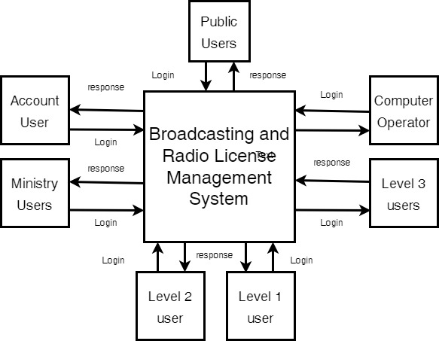

Figure 1DFD (0) User view

## 2.2. User Requirements

User Requirements for the "Broadcasting and License Management System" System are listed below:

1. **User Types (UR: 001)**

There should be basically nine types of user-types for this application i.e. Super Admin, Admin Users, Public Users, Computer Operators, Level 3 users, Level 2 users, Level 1 user, Account User and Ministry Users. Super Admin should have universal right for operating and managing the system. Super admin should create Admin who should have right to administer and manage the system configurations and to create other users as required. These user should be able to handle the system configurations and manage the application. In addition, Admin should have privilege to create as many user group as required.

Similarly, Public Users are the service seekers who will apply for permits and licenses and their sub-processes like renewal, royalty, bibaran pariwartan, import recommendation and Foreign Currency Exchange etc.

Computer Operators are the first person in DoIB who accept the documents provided by Public Users. Level 3 users generate Tippani for the request with complete information for processes and sub-processes and forward to Level 2 and Level 1 users of the system. Some processes like Frequency Assignment, Sajadaya Adesh and Foreign Currency Exchange System is also linked to Ministry level users who perform their respective task. Account Users of the system is responsible for verifying the receipt of each payment made by Public Users for different processes and sub-processes.

1. **Login (UR: 002)**

User should be able to log in to the system using their login credentials.

1. **Dashboard (UR: 003)**

User should be landed in the dashboard after login where they should have consolidated view of all the data from across all the interfaces of the application. This dashboard should show summary statistics of application data as mentioned below:

1. Notification of task to be performed
2. Recent Activities carried out
3. Collected Revenue
4. Total Registrations
5. List of requests
6. Graphical Illustrations
7. List of TODO Task
8. Highlighting notification message.

Each and every system information should be properly arranged and managed in the dashboard.

Similarly, all the system menus should be arranged in the sidebar. There should be proper placement of Logout, Profile and Change Password button. There should be highlighting notification message in the Dashboard.

User should have notification feature from which for every decisive action made on their application will be notified to them.

Dashboard for different level of users may be different based on their access levels which needs to be managed by Admin User of the system.

1. **Profile Management (UR:004)**

Users should be able to update and add their own profile information. They can view own profile information on the profile page. The list of information that should be shown in the users profile page are as below:

1. Organizational Details
2. Personal Details
3. Contact Information
4. Permanent and Temporary Addresses
5. Login Detail

Each profile information as above should be arranged in the tab with proper tab heading.

1. **Permit Management (UR: 005)**

Permit module should have all the features required to apply, process and issue the permit for FM, Television, Operator, Local Agent, Downlink, Digital Headend, Signal Distributor and Others. This module should be dynamic and highly configurable so that there should be specific required forms, formats, documents, checklists, permit fee, different level of approval process and specific letters to be generated by the system for each type of permit. This module should also have all the required features in order to automatically terminate the permit of any services based on the policy when any service provider fails to comply the required process.

1. **License Management (UR: 006)**

License module should have all the features required to apply, process and issue the License for FM, Earth Station, Digital Headend, Sales & Distribution, Walkie Talky, Link, Other transmitting station, Manufacturer, MHL, Satellite Phones, Satellite Callers, Satellite Receiver, Modems etc. This module should be dynamic and highly configurable so that there should be specific required forms, formats, documents, checklists, license fee, different level of approval process and specific letters, documents to be generated by the system for each type of license. This module should also automatically calculate the penalty based on the existing rules and regulations.

1. **Inspection Module (UR: 007)**

Inspection module should have all the features required to apply, process or extend the inspection process. This module should be dynamic and highly configurable so that there should be specific required forms, formats, documents, checklists, different level of approval process and specific letters, documents to be generated by the system for each inspection.

1. **Royalty Module (UR:008)**

Royalty module should have all the features required to apply, process or extend the inspection process. This module should be dynamic and highly configurable so that there should be specific required forms, formats, documents, checklists, royalty amount, different level of approval process and specific letters, documents to be generated by the system for each type of royalty payment. Royalty module should also automatically calculate the penalty based on the existing rules and regulations.

1. **Amendment Module (UR: 009)**

Amendment module should have all the features required to amend the information of existing Permit holder or License holder. Amendment may simply include the request to change the basic information or their existing service category. This module should be dynamic and highly configurable so that there should be specific required forms, formats, documents, checklists, fee/amount, different level of approval process and specific letters, documents to be generated by the system for each type of amendment.

1. **Penalization Module (UR: 010)**

When any agency who has previously obtained permit or license but has failed to comply with the routine process of updating, renewing, submitting documents, paying fees/amounts, there is a separate process of penalization through which, the agency again can continue its operation and services.

Penalization module should have all the features required to process and decide on the amount of penalty that the agency has to pay before re-starting its operation. This module should be dynamic and highly configurable so that there should be specific required forms, formats, documents, checklists, fee/amount, different level of approval process and specific letters, documents to be generated by the system for each type of penalization. Once the agency fulfills the decided penalization, it will be allowed to reapply for the permit from the start.

1. **Foreign Currency Recommendation Module (UR: 011)**

Foreign Currency Recommendation module should have all the features required to apply for the foreign currency exchange by a permit holder. This module should be dynamic and highly configurable so that there should be specific required forms, formats, purpose, documents, checklists, fee/amount, different level of approval process and specific letters, documents to be generated by the system for each type of foreign currency recommendation request.

1. **Import Recommendation Module (UR: 012)**

Import Recommendation module should have all the features required to apply for the import recommendation by a license holder. This module should be dynamic and highly configurable so that there should be specific required forms, formats, purpose, documents, checklists, fee/amount, different level of approval process and specific letters, documents to be generated by the system for each type of import recommendation request.

1. **Notification Module (UR: 013)**

The system should have three types of Notification Modules for sharing important information to all level of users.

**Email Notification:** The module should be able to send the automated emails to the internal users as well as external users upon any major events or progress of activities during the entire cycle of Permit, License etc.

**Application Notification:** The system should be able to send the real time notification upon different events occurring throughout the modules. This will help users to easily be notified and perform preferred tasks. Internal as well as external users will be able to view the notification from the application itself.

**SMS Notification:** The module should be able to send the automated SMS to the internal users as well as external users upon any major events or progress of activities during the entire cycle of Permit, License etc.

1. **Integration Module (UR: 014)**

The system should integrate with other systems like Document Management System, RMIS, Integrated Tax System and OCR System.

1. **User Management (UR: 015)**

Super Admin should have universal right in the system and should create different level of users of the system along with their roles and permissions.

1. **Configuration Management (UR: 016)**

The system should be parameter driven where admin can update the parameter as required.

1. **User Activity Logs (UR: 017)**

Admin should be able to view the system logs like Login Logs, Failed Login Logs, User Activity Logs etc.

## 2.3. Process Flow Diagrams

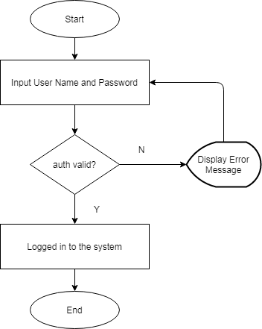

Figure 2 Login

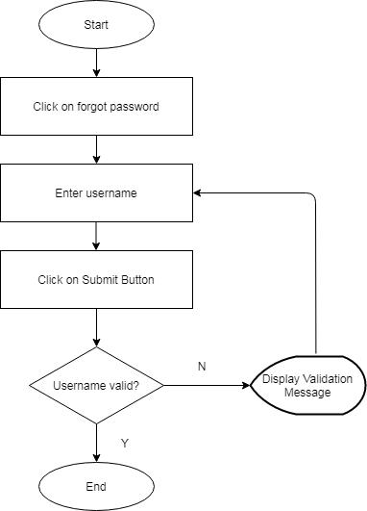

Figure 3 Forgot Password

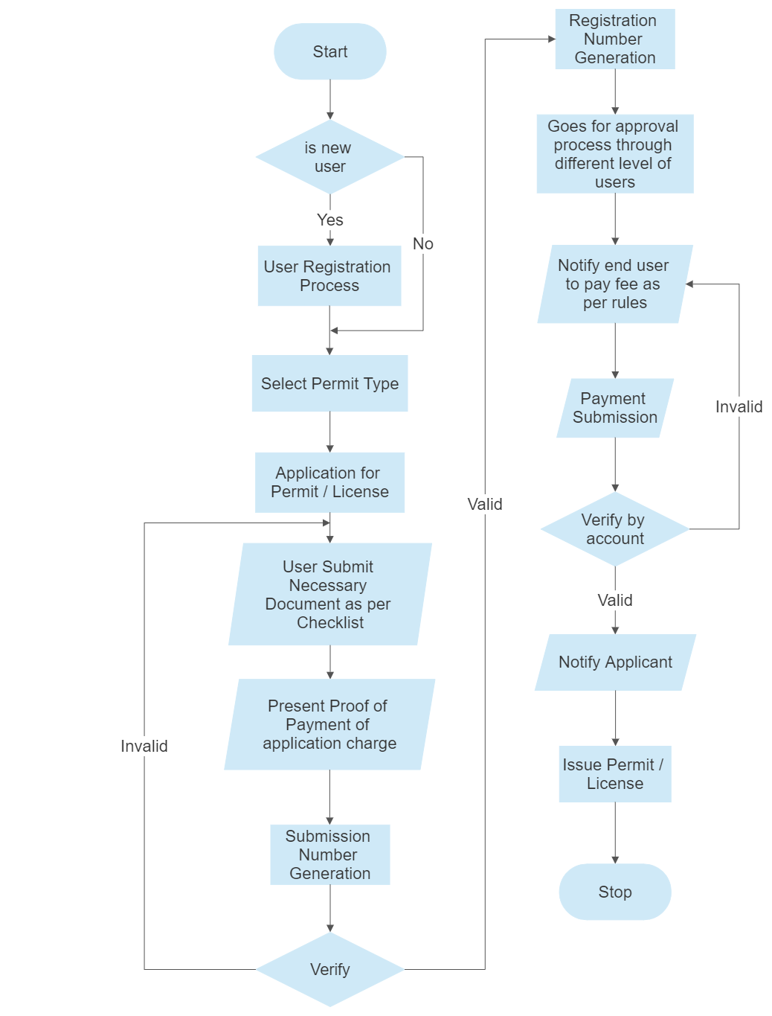

Figure 4 Permit/License General

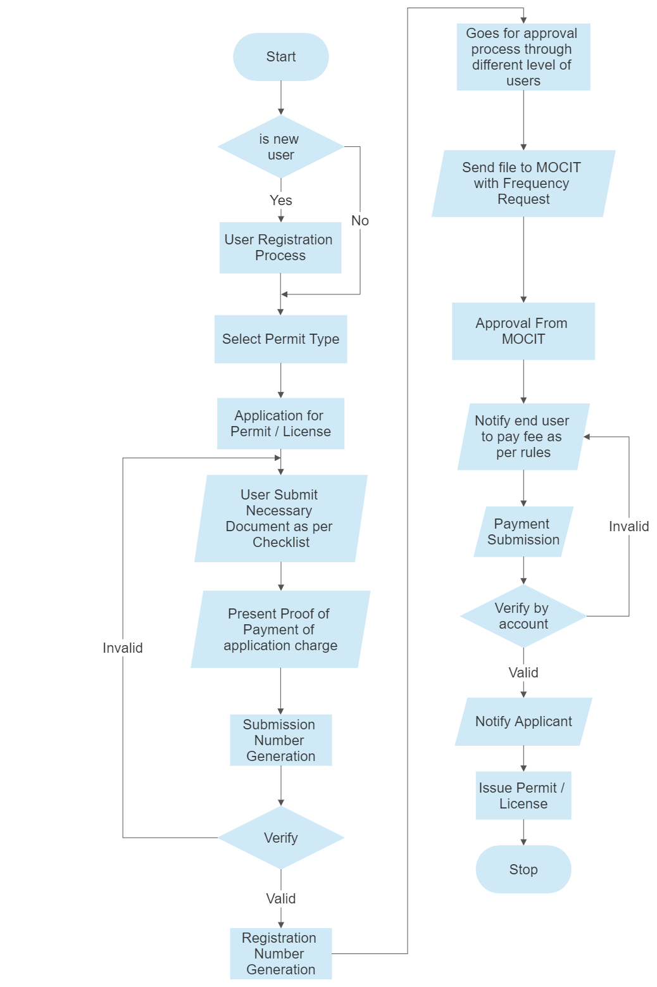

Figure 5 Permit FM

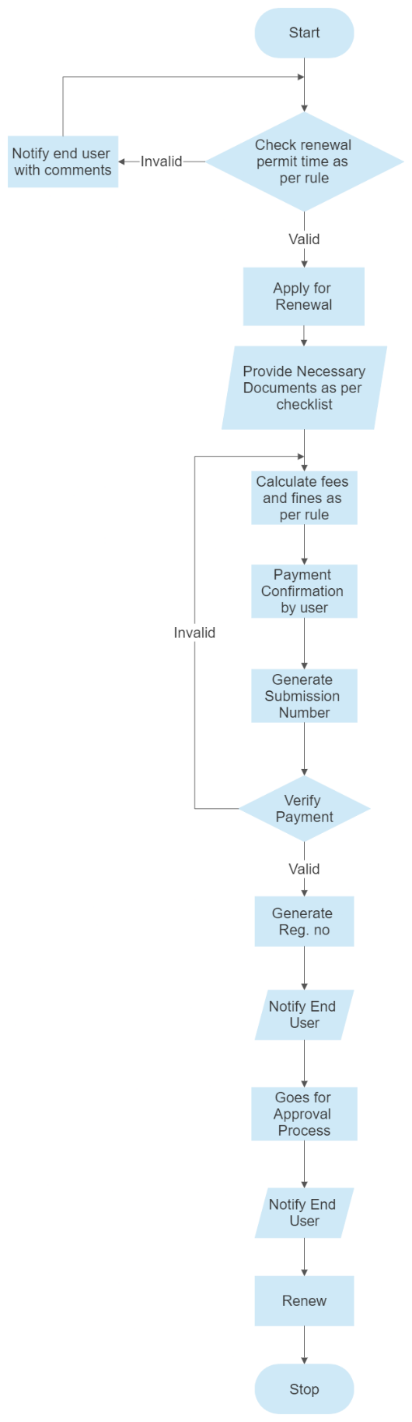Figure 6 Renewal of Permit/License

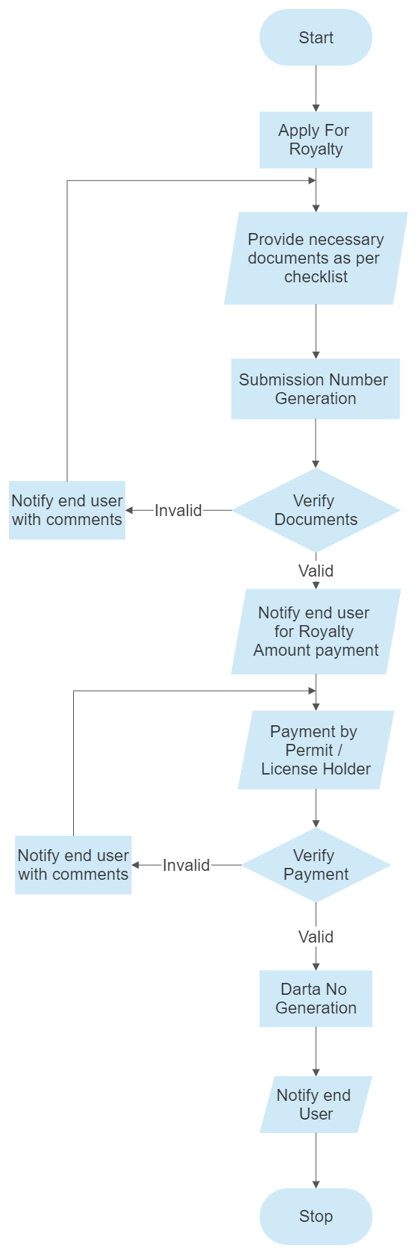

Figure 7 Royalty Payment Processing

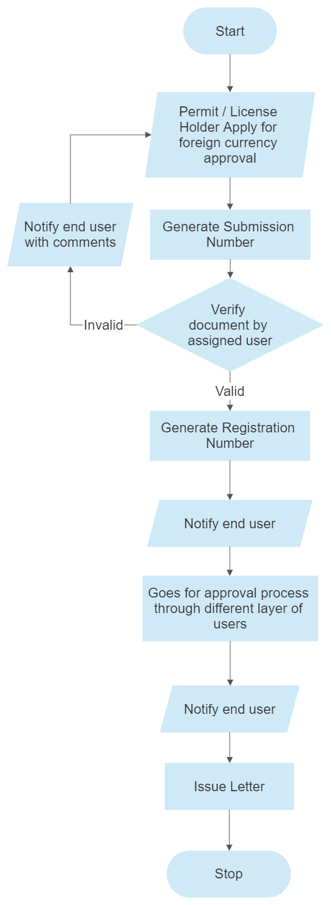Figure 8 Foreign Currency Exchange Processing

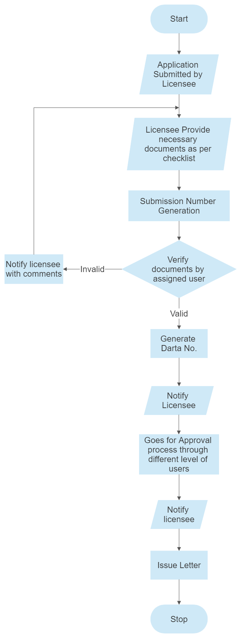Figure 9 Import Recommendation

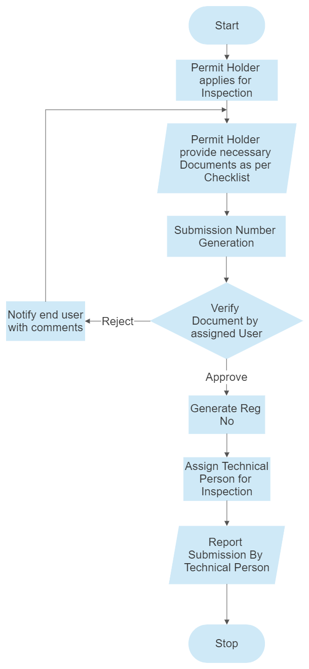

Figure 10: Inspection of FM/TV

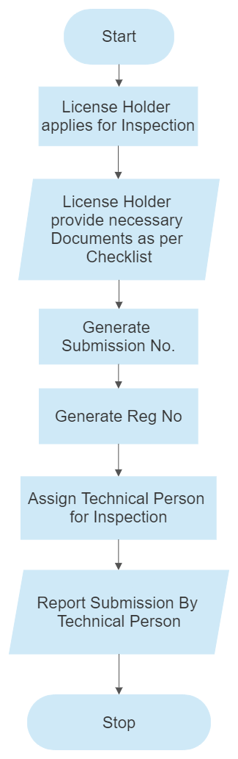

Figure 11: Inspection of Equipments

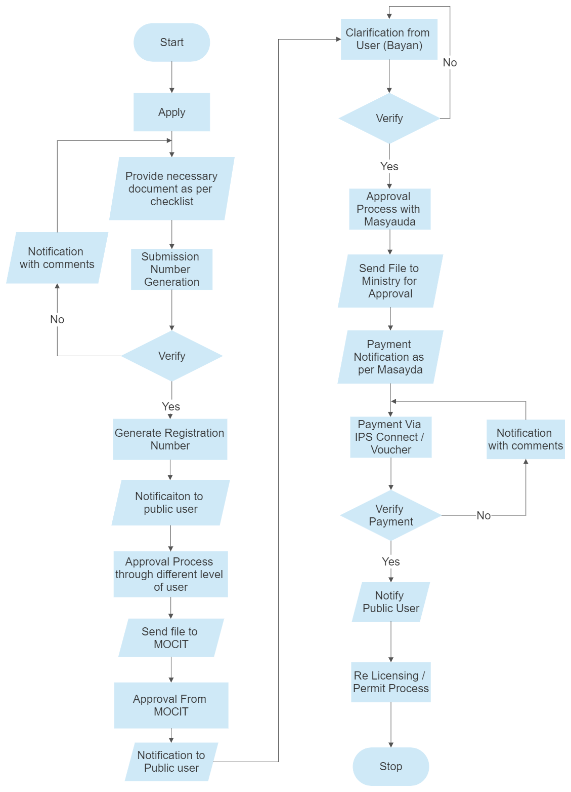Figure 12: Sajaya Adesh Processing

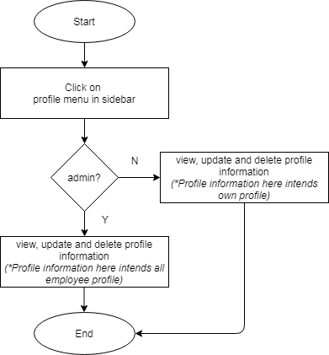

Figure 13 Profile Management

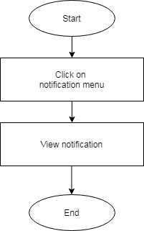

Figure 14 Notification Management

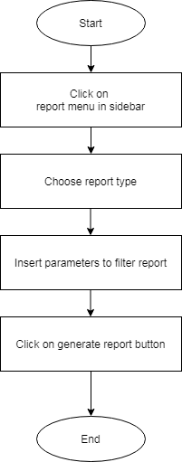

Figure 15 Reports

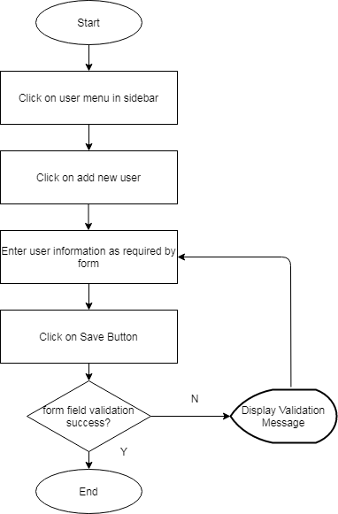

Figure 16 User Management

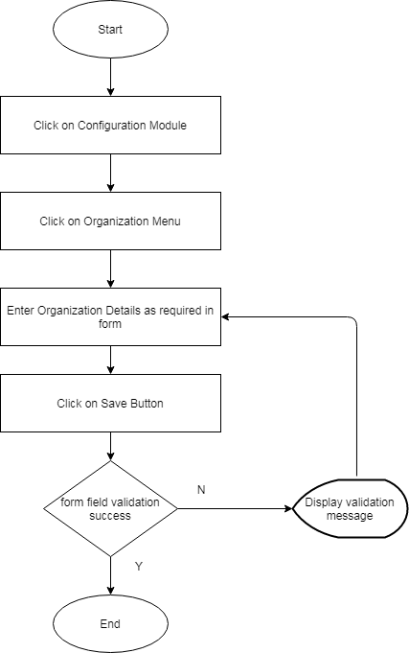

Figure 17 Configuration: Organization Management

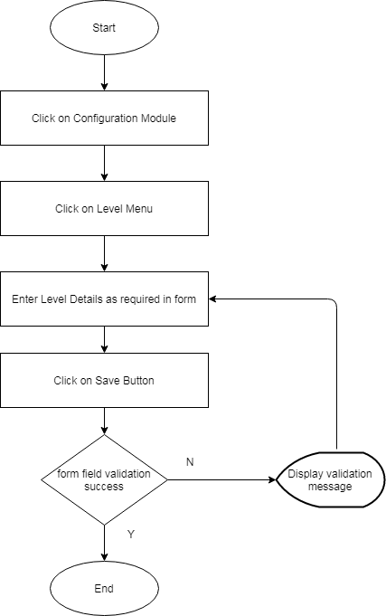

Figure 18 Configuration: Level Management

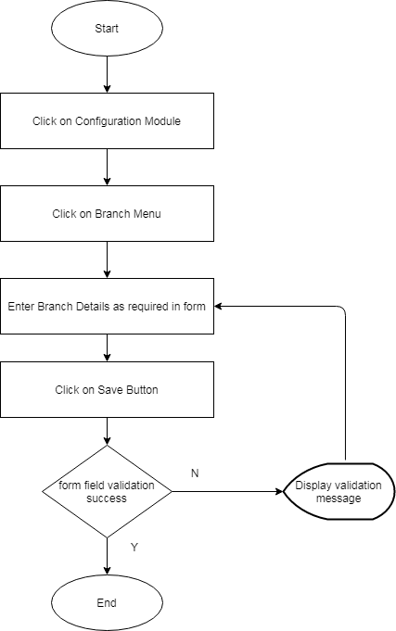

Figure 19 Configuration: Branch Management

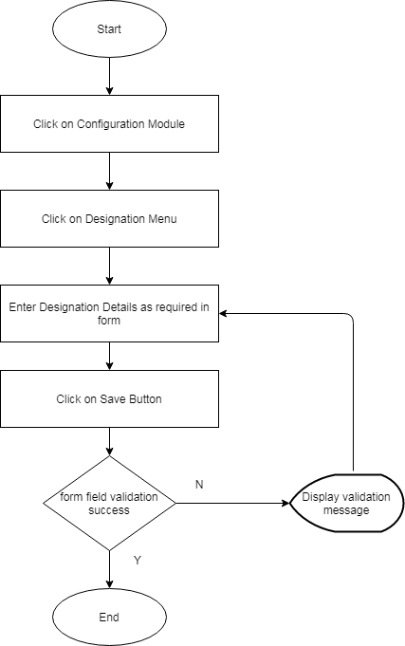

Figure 20 Configuration: Designation Management

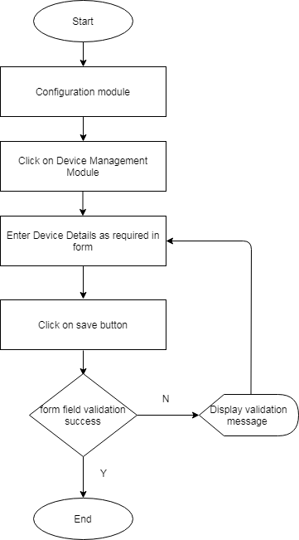

Figure 21 Configuration: Device Management

## 2.4. Functional Requirements

### 2.4.1. Functional RequirementGroup1: User Authentication/Access

#### 2.4.1.1. Login (FR: 001)

1. Login Page should have Username and Password field to enter the login credentials.
2. User Name field should accept both alphanumeric value.
3. Password field should accept alphanumeric and special character. The password length should be at least six digit character.
4. Username and Password field should have proper validation defined
5. The login page should have **remember me** checkbox. Clicking the **"remember me"** box should tell the browser to save cookies so that if user close out the window without signing out, the next time user go back, s/he will be signed back in automatically.
6. Clicking the sign-in button should check the user authentication and if success the system should move the user inside system dashboard. If authentication failed, the system should flash message **“Wrong Username and Password"** and should stay in the login page**.**
7. Disclaimer or Copyright outline should be mentioned in the Login Page with proper hyperlink.

#### 2.4.1.2 Logout (FR: 002)

1. The system should have logout button/link clicking which user should be logged out from the system moved to the login page. Clicking logout button should destroy the current session and redirect to the login page.

#### 2.4.1.3 Forgot Password (FR: 003)

1. There should be a forgot password link in the login page where on clicking the link, it should redirect to Forgot Password Page
2. Forgot password page should have form containing Username field, Cancel and Submit Button.
3. On Clicking the submit button, the system should send the auto generated password over the user email if the username is valid. If not, the system should display proper error message.
4. On clicking the cancel button, the system should redirect to the login page.

#### 2.4.1.4. Password Change (FR: 004)

1. The system should have Change Password Link
2. On clicking the link, change password form should be displayed.
3. Change password form should have password input fields on the right side containing:
4. Current Password Input Field
5. New Password Input Field
6. Confirm Password Input Field
7. Password field should accept alphanumeric and special characters and should accept minimum password length of six character.
8. The form should have Submit and Cancel Button. On clicking the submit button, the system should validate the data of New Password and Confirm Password. If matched, the password should be successfully updated else the system should notify **"New Password and Confirm Password did not matched".**
9. On clicking cancel button, password should not be updated and the pop up form should be closed.

### 2.4.2 Functional RequirementGroup2: Dashboard

The Dashboard should be the landing page which should contain the following information.

#### 2.4.2.1 Notification (FR: 005)

1. The Dashboard should have notification icon to see the notifications by all level of users
2. On clicking the notification icon, it should display ten recent notifications of user
3. On click see all notifications, user should get a page where the list of notifications are displayed in chronological order by datetime descending

#### 2.4.2.2 Recent Activities (FR: 006)

1. The Dashboard should show the recent activities carried out by the user in the system
2. On Clicking the Show All, the page should be appeared displaying 50 recent activities carried out by the user
3. Pagination should be there in the page so that user can navigate to other pages to see the activities

#### 2.4.2.3 Total Requests (FR: 007)

1. The Dashboard should show total number of requests for processes and sub-processes
2. On click the total request system should display the page showing all the unseen requests

#### 2.4.2.4 Scrolling notifications (FR: 008)

1. The Dashboard should show the scrolling list of high priority notifications
2. The high priority notifications should blink to get the attraction of the user
3. On clicking the highlighted notification the user should be sent directly to actions to be taken in the notification

#### 2.4.2.5 Total Revenue Information (FR: 009)

1. The Dashboard should show total revenue this month by processes to users of DoIB

#### 2.4.2.6 Graphical Illustrations (FR: 010)

1. The Dashboard should show graphical illustrations of the status of registrations, renewal and royalty of major processes in form of Bar Graph and Charts

#### 2.4.2.7 List of Menus (FR: 011)

1. The Dashboard should show the list of menu for all types of users based on their permission
2. On clicking the Menu the user should be sent to the list view of respective menus. The menus on the left corner of dashboard could have following things:
3. Permit
   1. FM
   2. Cable TV
   3. Satellite TV
   4. MMDH
   5. DTH
4. License
   1. Signal Distributor
   2. Walkie Talkie
5. Reports

### 2.4.3. Functional RequirementGroup3: Configuration Management

#### 2.4.3.1 Office Types Management (FR: 012)

1. Admin user can see the list of Office Types on Clicking Office Type
2. Admin user can Add New Office Type, the Office Type form should be shown containing following fields:
   1. Name
   2. Status
3. The system should perform validation on submission
4. The form should contain Cancel and Submit Button
5. On Clicking the Submit Button, the form should be submitted
6. On Clicking the Cancel Button, the form should be closed and list view of Office Type should be shown.
7. Similarly, on clicking the Export button, system should export the Office Types in csv format.
8. Similarly, on searching data, system should display the searched result.

#### Office Management (FR: 013)

1. Admin user can see the list of Offices on Clicking Office
2. Admin user can Add New Office, the Office form should be shown containing following fields:
   1. Name of Office
   2. Office Type
   3. Contact person
   4. Contact Number( 2numbers)
   5. Email Address
   6. Geographical Address (Province, District, VDC/Municipality, Ward No., Tole)
   7. Status
3. The system should perform validation on submission
4. The form should contain Cancel and Submit Button
5. On Clicking the Submit Button, the form should be submitted
6. On Clicking the Cancel Button, the form should be closed and list view of Office should be shown.
7. Similarly, on clicking the Export button, system should export the Office in csv format.
8. Similarly, on searching data based on Name, Office Type and Address, system should display the searched result.

#### Designation Management (FR:014)

1. Admin user can see the list of Designation on Clicking Office
2. Admin user can Add New Designation, the Designation form should be shown containing following fields:
   1. Name
   2. Status
3. The system should perform validation on submission
4. The form should contain Cancel and Submit Button
5. On Clicking the Submit Button, the form should be submitted
6. On Clicking the Cancel Button, the form should be closed and list view of Designation should be shown.
7. Similarly, on clicking the Export button, system should export the Designation in csv format.
8. Similarly, on searching data based on Name system should display the searched result.

#### Position Management (FR:015)

The functional requirement is same as Designation Management with fields Name, Designation, Status and search with Name and Designation.

#### Country Management (FR:016)

Similar to functional requirements of earlier configurations Country Management includes fields like Country Name, Country Code and Zipcode.

#### Staff Management (FR:017)

Similar to functional requirements of earlier configurations Staff Management includes Name of Staff, Office Type, Office, Designation, Position, Department, Permanent Address, Temporary Address, Phone Number, Email, Karmachari Sanket Number.

#### Department Management (FR:018)

Department Management includes the Name of Department and Office in which department belongs to.

#### Language Management (FR: 019)

Language Management includes the Name of languages in which broadcasting is possible.

#### Device Management (FR:020)

Device Management includes the device information.

#### Program Type Management (FR:021)

Program Type Management includes the list of Program Type.

#### Bank Management (FR:022)

Bank Management includes the bank from which user can submit the fees.

#### Cost Center Management (FR:023)

Cost Center Management includes the fees for different processes and sub-processes.

#### Fine Management (FR:024)

Fine Management includes the Fines allocated for delay of each processes and sub-processes.

#### Document Checklist Management (FR:025)

Document Checklist Management includes the lists of checklist of documents to be provided by Public Users to DoIB for different processes and sub-processes.

#### File Number Management (FR:026)

File Number Management includes the table which contains the latest file number for Permits and Licenses.

### 2.4.4. Functional RequirementGroup4: Permit Management

#### 2.4.4.1 Permit Request (FR: 027)

1. System should have feature to request for New Permit Request and entry of old Permits owned by Public Users.
2. On clicking the New Permit Request, the system should display the Permit Request page with Permit Form and Checklist attachment.
3. The form should contain Cancel Button to cancel the Permit Request
4. Similarly, on clicking the Export button, system should export the Permit Requests in csv format.
5. Similarly, on searching data, system should display the searched result.
6. The system should perform validation on submission
7. The system should have save button to save the contents entered in the form and stay on that page
8. The system should have save and exit button which displays the list of Permit Requests after saving the form
9. The system should have Submit button clicking on which submits the document to DoIB.
10. After submission of the document the Public Users should have view only permissions in the request.

#### 2.4.4.2 Tippani Generation and Approval (FR: 028)

1. The list of Permit Requests with all the documents verified should be displayed to the Level 3 user

2. Level 3 user should have permission to generate Tippani for the particular Permit Request based on the pre-defined template

3. Level 3 user should see the permit request data automatically field in Tippani

4. Level 3 user should be allowed to change the Tippani contents and the Tippani format should be editable.

5. Level 3 user should have options to Forward Tippani to next level of user based on the permission assigned.

6. Level 3 user should sign the Tippani using Digital Signature before forwarding the documents to Next User Level.

7. The Tippani processes with Forward, Raya Sallah and Reject options for Level 3 user, Level 2 user and Level1 user.

#### 2.4.4.3 Frequency Assignment (FR: 029)

1. For permits that requires Frequency Assignment the form is sent to Ministry for Frequency Assignment.

2. The assigned user should haveIPS options to Forward the Permits to Ministry

3. Ministry Level users should have options to assign or reject the Frequency Assignment for particular request.

#### 2.4.4.4 Payment Processing and Authorization (FR: 030)

1. For all the forms related to permit in which cost is associated for Nibedan and Permit Fee options should be provided to make payment.

2. Payment should be made by IPSCONNECT and bank voucher upload by Public Users

3. After the payment is done by Public Users it needs to be verified by account user before further processing.

### 2.4.5. Functional RequirementGroup5: License Management (FR: 031)

All the functional requirements of License Management is similar to Permit Management.

### 2.4.6. Functional RequirementGroup5: Renew Management (FR: 032)

1. After the permit and license issue the Public Users are able to request for annual renewal of Permit and License.

2. The system should check whether the Permit and License renewal is allowed for the respective process based on past renewal and Inspection.

3. System should have Add Renew Request which displays the form with checklists required for renewal.

4. After the submission of forms and checklist document the system should have options to save, save and exit and submit button for further processing

5. System should automatically create the Fees and Fines requirements for renewal process.

### 2.4.7. Functional RequirementGroup5: Royalty Management (FR: 033)

1. After the permit and license issue the Public Users are able to request for annual Royalty of Permit and License.

2. The system should check whether the Permit and License Royalty Payment is allowed for the respective process based on past renewal and Inspection.

3. System should have Add Renew Request which displays the form with checklists required for royalty processing.

4. After the submission of forms and checklist document the system should have options to save, save and exit and submit button for further processing

5. System should automatically create the Fees and Fines requirements for Royalty process.

### 2.4.8. Functional RequirementGroup5: Sajaya Adesh Management (FR: 034)

1. Sajaya Adesh processing options should be in system for Terminated Permits and Licenses

2. Sajaya Adesh request is made by Public Users and processed by DoIB users which is also forwarded to ministry level users for verifications.

### 2.4.9. Functional RequirementGroup5: Foreign Curency Exchange Management (FR: 035)

1. System should have options to initiate Foreign Currency Exchange Management by Public Users

2. Public Users should get the form to fill the foreign currency information and contract made with third party.

### 2.4.10. Functional RequirementGroup5: Import Recommendation Management (FR: 036)

1. System Should have options for Import Recommendation for devices and equipments.

### 2.4.11. Functional RequirementGroup5: Integration Management (FR: 037)

1. System should have options to integrate the BRLMS with other systems like OCR, Integrated Tax System, Document Management System and Digital Signatures.

### 2.4.12. Functional RequirementGroup6: Profile and Notification Management

#### 2.4.6.1 Profile Management (FR: 038)

1. The system should allow user to view and update Employee Profile in each tab. On clicking each tab, the information should be loaded.
2. The system should display the employee profile details. The profile details should contain:
3. Personal Details
4. Job Details

#### 2.4.6.2 Notification Management(FR: 039)

1. The system should notify users in below mentioned action:
2. Leave Approval
3. Leave Recommendation
4. Kaaj Approval
5. Kaaj Recommendation
6. The system should show notification on Leave Approve/Reject, Kaaj Approve/Reject, Recommended Leave Approve/Reject

### 2.4.13. Functional RequirementGroup8: User Management (FR:040)

1. The system should have feature to create the user.
2. The User Page should have list of all created users along with create new user function, import function, search function, filter function
3. On clicking the Create new user button, the user should be navigated to the Add new user form
4. The system should check for below validation while creating the user
5. The pop up form should have save and cancel button. On clicking save, the information should be saved in the database whereas on clicking cancel will cancel the user creation process.
6. All the created user should be listed in the User page.
7. User page should have **Add new**, **Export** and **Print Button.**
8. User page should have edit button for each row in the list
9. System should have option to allow user information search.

### 2.4.15. Functional RequirementGroup8: Reports (FR:041)

1. The system should allow to generate customizable reports.
2. The system should allow users to export the reports in PDF, Excel Format
3. The system should have filter option to filter the reports as per the parameters

# 3. Other Requirements

## 3.1. Interface Requirements

Below are the interface that are needed in the BRLMS System:

1. Login Interface

This interface should contain below functionalities:

1. User Name
2. Password Input Field
3. Declaimer Message: Copyright to DoIB
4. Sign in Button
5. Remember me checkbox
6. Forgot Password
7. Username field with proper label along with footnote
8. Cancel and Submit button
9. Change Password
10. In left component: User Image, User Name, ID, Mobile, Email
11. In right component : Current Password field, Password field, Confirm Password field
12. On Pop up page footer: Cancel Button and Submit Button
13. Dashboard

**In Body:**

1. Component Box for showing Total Revenue, Total Registrations, Recent Activity, TODO Task
2. Listing of all the Pending Task
3. Listing of all the Pending Request
4. List of all the Notification
5. Display of Graph for Registration, Renewal, Royalty, Foreign Currency Exchange etc

**In Sidebar:**

1. Module Listing: Permit, License, Foreign Exchange System, Import Recommendation, Reports

**In Header:**

1. Notification
2. Change Password
3. Profile
4. Logout
5. User Profile

**In Left Component:**

1. Users Image
2. Name
3. Designation
4. E-mail
5. Mobile Number
6. Permanent and Temporary Address
7. Contact Information

**In Right Component :**

1. Tab View : Personal Details, Organizational Details
2. On each tab, the information should be shown as per FR: 024

## 3.2. Hardware Interfaces

The system should support below hardware interfaces:

|  |  |
| --- | --- |
| Interface Name | Physical address |
| USB port | Physical address 1 |
| Ethernet Interface | Physical address 2 |
|  | Physical address n |

## 3.3. Software Interfaces

*This application "Broadcasting and Radio License Management System" is standalone application and is engaged with other application software for any kind of data exchange and interface use.*

*Document Management System – Exchange of Documents*

*RMIS – Exchange of Payment Information*

*Integrated Tax System – Obtains information about Tax Registration and Renewal information ( If API provided by Integrated Tax System)*

*OCR System – Obtains information about the registration information of organization (If API provided by OCR System)*

## 3.4. Data Conversion Requirements

1. Every information of user is associated with USERID
2. USERID should be unique
3. Each Permit has separate File Number
4. All the License information of the user are maintained in same file with same file number
5. Each submissions are maintained through Submission Number which should be randomly generated 10 digit alphanumerical character

## 3.5. Hardware/ Software Requirements

This section describes description of hardware/software requirements needed to operate the application.

## 3.5.1 Hardware Requirements

1. **PC Requirement**
2. Processor- Quad Core or Above
3. RAM- 6GB or above
4. Hard disk- 10TB or above
5. Monitor- 14" VGA or above
6. Mouse, Keyboard with 101 keys
7. **Server Requirement**
8. Cent OS
9. Storage: 10 TB

### 3.5.2 Software Requirements:

1. Any Linux based operating system
2. PostGRESQL as database
3. Browsers: Internet Explorer, Mozilla Firefox, Google Chrome, Safari, Brave etc.

# 4. Operational Requirements

## 4.1. Security and Privacy

For the Broadcasting and Radio License Management System, the system should have below mentioned Security and Privacy Requirements:

1. Loss or Corruption of data
2. The system should have proper mitigation mechanism for loss and corruption of data.
3. The system should have proper backup mechanism as Daily backup, Weekly backup, Monthly Backup
4. The system should have data recovery service
5. The system should have proper Disaster Recovery Plan to spring into the action the moment a disaster occurs to minimize the data loss
6. Disclosure of secrets or sensitive information
7. The system should have proper data confidentiality management to prevent leakage of secrets or sensitive information.
8. The system should check and monitor the leakage of sensitive information
9. The system should encrypt the data to secure it from misuse or leakage
10. Disclosure of privileged/privacy information about individuals
11. Corruption of software or introduction of malware, such as viruses
12. The handling mechanism should be developed for controlling the corruption of software, malware detection such as viruses
13. The hosted server for the application should have proper physical security. Unauthorized persons should be prevented from entering into the server room
14. The system should have proper access control mechanism defined where the users will only operate the system and can have access to the functional modules as per the roles and permissions defined.
15. The Super Admin should have option to dynamically allocate the roles /permission to the other system user group.
16. Super Admin should have universal right on using the BRLMS where they can create other users and user group, allocate permissions and manage other system configurations
17. Super Admin should have right to read, write, update and delete the data in the system. They can view and monitor the system logs as well as have all the system universal data available to them.
18. Admin user will be one step below user than the super admin who have right to manage the system configurations and user management but only as per the stated condition defined by the Super Admin
19. Other usergroups user should have right to view and update their information/data in the system but do not have other right like managing configurations, viewing logs etc.

## 4.2. Audit Trail

1. The system should have proper log module that help administrator to track the changes made in the system database
2. The system should have proper Login Log module that help administrator to track and monitor the Login and Failed Login Logs.

## 4.3. Recoverability

1. The system should have fast recovery time from the state of system downtime. For this the system should have two instances created one should be live system running while other should be replica of live application. In case of emergency failure, the replica of the live application should run as primary application until the recovery of live application
2. There should be proper data backup strategy implemented for the application
3. For hardware backup, multiple backup systems should be maintained so that in incase one hardware falls, other will run as backup.
4. In case of database is corrupted, the database must be capable of being restored to its condition of no more than 2 hours

## 4.4. System Availability

1. The application must be available to users 24 hrs all the time
2. The system unavailability should be least acceptable on Time 9:00am-11:00 am and 5:00 pm to 6:00 pm
3. All the system maintenance should be carried out only on less peak hour mainly between 12:00pm to 3:30 pm.
4. Proper DR Planning and Reduction in single point of failure should be maintained in order to have system availability

## 4.5. General Performance

1. The response time for queries and updates for BRLMS should be maximum of 5 Sec .i.e. **Response time ≤ 5sec.**
2. The throughput for the BRLMS should be 500 tps
3. Expected rate of user activity : 10k transaction per hr

**Hardware Performance**

1. Face Capacity: 3k +
2. Record Capacity : 5 lakh +
3. Fingerprint Capacity: 3k +

## 4.6. Capacity

The BRLMS should handle the capacity of 500 concurrent users at a time.

## 4.7. Data Retention

1. The system should not allow user to delete the data permanently. The system should have soft delete feature so that the deleted data should be archived in the database. The archived data shall be retained whenever required.
2. The data that should be retained are submitted document information, deleted rows etc

## 4.8. Error Handling

1. Proper error handling should be handled in the system.
2. The system should have error response to abnormal input or conditions
3. The system should have proper exception handling
4. Different types of errors should be handled by the system like Run Time Error, Logic Error.
5. All the countered errors should be properly handled by using debugger.

## 4.9. Validation Rules

1. The system should restrict the data using the validation rule
2. The system should have field validation rules defined to specify a criterion that all valid field values must meet.
3. The system should have record validation rules defined to specify a condition that all valid records must meet.
4. The system should have proper validation defined on a form to specify a criterion that all values input to that control must meet.
5. Proper validation rule should be defined as Client side Validation, Server Side Validation and Database Validation

## 4.10 Conventions/ Standards

Below are the conventions and standards that this system should follow:

1. Proper Folder/ Naming Conventions should be defined.
2. Define proper naming conventions for multiple functional parts of a program like:
3. Variables
4. Methods
5. Classes
6. Constants
7. Programming Language
8. Better Coding Style with improved code quality
9. Code Review Standard in order to provide the coding style
10. The structural formatting should be defined as conventions for coding standard
11. Proper use of braces should be defined
12. Use of whitespace to format code for readability with conventions such as adding spaces to comma separated lists, adding line breaks between semantically separate code blocks, and adding spaces between tokens in a list of conditions or an operation statement.

# APPENDIX-A-GLOSSARY

|  |  |
| --- | --- |
| SRS | Software Requirement Specification |
| API | Application Programming Interface |
| GEA | Government Enterprise Architecture |
| FR | Functional Requirement |
| UR | User Requirement |
| DOIB | Department of Information and Broadcasting |
| IDE | Integrated Development Environment |
| RAM | Random Access Memory |
| VGA | Video Graphics Array |
| USB | Universal Serial Bus |
| IP | Internet Protocol |
| BRLMS | Broadcasting and Radio License Management System |

# APPENDIX-B- Assumptions, Constraints and Non-Functional Requirements

## Assumptions

1. We assume that the within the organization there should be proper facility of the internet connectivity. We assume high internet connectivity to handle the large number of user request.
2. We assume that the resources assigned for Requirement Gathering and Verification of system as per requirements doesnot changes throughout the project
3. We assume each changes beyond the scope of work are well documented

## Constraints

1. All the requirement documented should be valid to carry out the application development.

## Non Functional Requirements

1. Performance : The system should have efficient response time
2. Scalability: The proposed system must be adaptable to the changing needs or demands of its users and clients
3. Responsiveness
4. Usability: The proposed system should be easy to use and navigate for the end users.
5. Reliability : The proposed system and its components should be able to perform its required functions under stated conditions for specified amount of time
6. Documentation: The proposed system should have proper documentation maintained.
7. Availability: The proposed system should be functional and operational 24*7.